Captcha Verification

🤖 What is CAPTCHA Verification?
# Source: AI Source: Provided by: [Data Path: Persons Table -> ID Column: 1, Name_En Column: Motasem Essam] -> From: [ChatGPT] on [1/18/2026]
CAPTCHA stands for:
Completely Automated Public Turing test to tell Computers and Humans Apart.

🔐 CAPTCHA Verification
# Source: AI Source: Provided by: [Data Path: Persons Table -> ID Column: 1, Name_En Column: Motasem Essam] -> From: [ChatGPT] on [1/18/2026]
CAPTCHA verification is a security test that confirms a user is human, not a bot. It prevents automated abuse of websites — like spam, fake account creation, or brute-force login attacks.

🧠 Why It’s Used
# Source: AI Source: Provided by: [Data Path: Persons Table -> ID Column: 1, Name_En Column: Motasem Essam] -> From: [ChatGPT] on [1/18/2026]
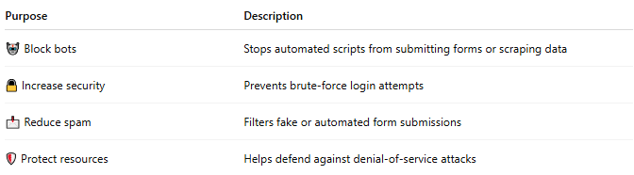

Purpose | Description
🤖 Block bots | Stops automated scripts from submitting forms or scraping data
🔒 Increase security | Prevents brute-force login attempts
📩 Reduce spam | Filters fake or automated form submissions
🛡️ Protect resources | Helps defend against denial-of-service attacks

🔍 Common CAPTCHA Types
# Source: AI Source: Provided by: [Data Path: Persons Table -> ID Column: 1, Name_En Column: Motasem Essam] -> From: [ChatGPT] on [1/18/2026]
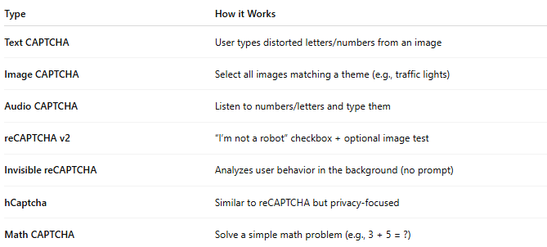

Type | How it Works
Text CAPTCHA | User types distorted letters/numbers from an image
Image CAPTCHA | Select all images matching a theme (e.g., traffic lights)
Audio CAPTCHA | Listen to numbers/letters and type them
reCAPTCHA v2 | “I’m not a robot” checkbox + optional image test
Invisible reCAPTCHA | Analyzes user behavior in the background (no prompt)
hCaptcha | Similar to reCAPTCHA but privacy-focused
Math CAPTCHA | Solve a simple math problem (e.g., 3 + 5 = ?)

⚙️ CAPTCHA Providers
# Source: AI Source: Provided by: [Data Path: Persons Table -> ID Column: 1, Name_En Column: Motasem Essam] -> From: [ChatGPT] on [1/18/2026]
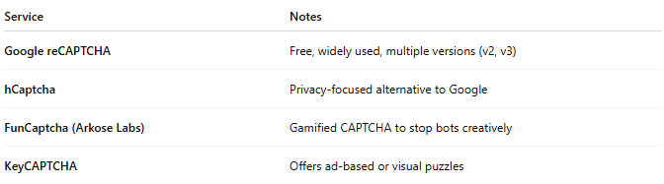

Service | Notes
Google reCAPTCHA | Free, widely used, multiple versions (v2, v3)
hCaptcha | Privacy-focused alternative to Google
FunCaptcha (Arkose Labs) | Gamified CAPTCHA to stop bots creatively
KeyCAPTCHA | Offers ad-based or visual puzzles

🔁 CAPTCHA Verification Flow
# Source: AI Source: Provided by: [Data Path: Persons Table -> ID Column: 1, Name_En Column: Motasem Essam] -> From: [ChatGPT] on [1/18/2026]
- User submits a form (e.g., login, signup, contact)
- CAPTCHA is displayed
- User completes the test (proves they’re human)
- If passed → proceed
If failed → block or retry

🧪 Example: Google reCAPTCHA v2 (PHP)
# Source: AI Source: Provided by: [Data Path: Persons Table -> ID Column: 1, Name_En Column: Motasem Essam] -> From: [ChatGPT] on [1/18/2026]
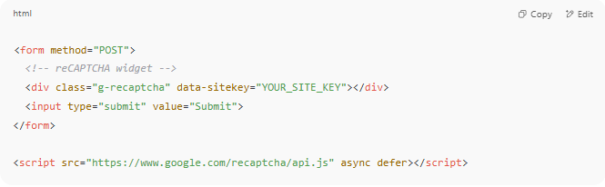
<form method="POST">
<!-- reCAPTCHA widget -->
<div class="g-recaptcha" data-sitekey="YOUR_SITE_KEY"></div>
<input type="submit" value="Submit">
</form>

<script src="https://www.google.com/recaptcha/api.js" async defer></script>

In PHP backend:
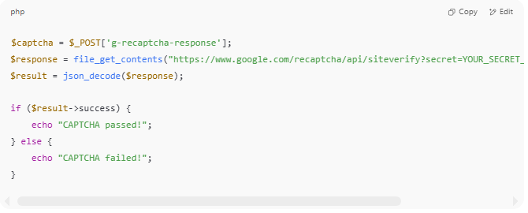
$captcha = $_POST['g-recaptcha-response'];
$response = file_get_contents("https://www.google.com/recaptcha/api/siteverify?secret=YOUR_SECRET_KEY&response=".$captcha);
$result = json_decode($response);

if ($result->success) {
echo "CAPTCHA passed!";
} else {
echo "CAPTCHA failed!";
}

